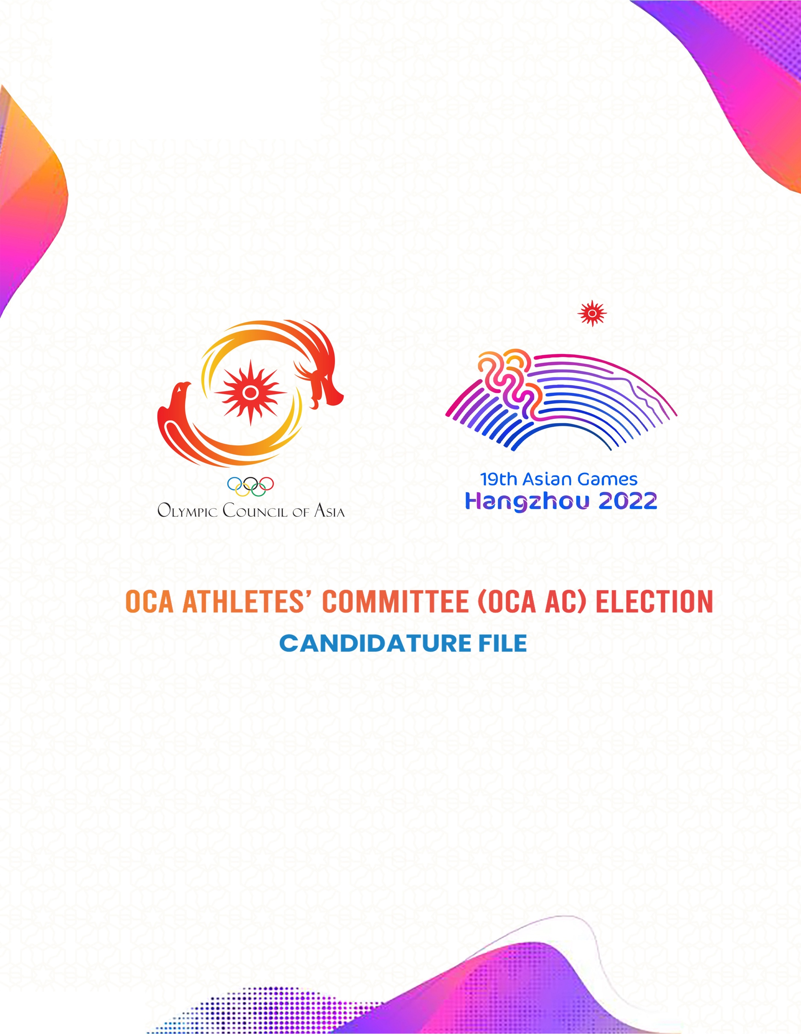

DOCUMENT 1
CANDIDATURE PROPOSAL FORM
TO BE COMPLETED AND SIGNED BY THE CANDIDATE AND THE NOC

Family name of the candidate: | Given name of the candidate:
.  Gender: Male Female  Date of Birth (dd/mm/yyyy): | National Olympic Committee:
.Mother tongue:  Other language(s) spoken and level*:  *English is mandatory | Sport:  Discipline/Event(s):
In which Asian Games did the candidate compete or will complete?
19th Asian Games Hangzhou 2022
18th Asian Games Jakarta/Palembang 2018
17th Asian Games Incheon 2014
Do you have an NOC Athletes’ Committee?  Yes  No | Is the candidate a member of your NOC Athletes’ Committee?  Yes-How long has he/she been a member?  No
Is the candidate a member of his/her IF/AF Athletes’ Committee?  Yes-How long has he/she been a member?  No | Has the Athlete received any sanctions in relation to the world Anti-Doping Code?  Yes  No

DOCUMENT 2
BIOGRAPHY AND STATEMENT BY THE CANDIDATE
1. BIOGRAPHY
To be completed by the candidate
The biography must be typed below and should not exceed 800 to 1,100 characters (including spaces) in total.

SPORTS CAREER-MAIN RESULTS
 | Year | Sport/ Discipline/Event | Results/Ranking
OLYMPIC GAMES

ASIAN GAMES

INTERNATIONAL
COMPETITIONS

OTHER CONTINENTAL COMPETITIONS

PROFESSIONAL CAREER
List in chronological order in the grouping below.
Education/studies
Type of qualification-subject-year obtained-name of university.

Professional activities
Job title-name of the company

Functions in the field of sports administration (Athletes’ Committee, NOC, IF, AF, NF…)
Job title-name of the organization

Membership of other associations

List of chronological order the positions held in associations that are not linked to the world of sport.

Awards and distinctions

List of chronological order any awards and distinctions received.

Other activities

List in chronological order the role and positions held in citizen movements that are not related to the world of sport, plus any other charity initiative.

2-STATEMENT
(To be written by the candidate)
Please explain why you wish to become a member of the OCA Athletes’ Committee.
The statement must be typed in the box below and should not exceed 1,100 characters (including spaces). The message should be addressed to the athletes, encouraging them to vote for you.

In addition, please answer the questions below. This information will not be used as part of the analysis of the candidature file (200 characters max. for each question including spaces):
1-Why are you running as a candidate for the OCA Athletes’ Committee?
2- What experience do you have that you would bring to the OCA AC?

3-Why should your fellow athletes vote for you?

4- What is the biggest challenge you have faced as an athlete?
5-How did you become involved in sport?

6-How has sport had an impact on your life?

7- What would be your top three priorities if you were elected?

8-Describe your personality in three words?

9-What are your passionate about?

10-Why is the athletes’ voice important to you?

Document 3
ATHLETES’ COMMITTEE INFORMATION REQUIRED
To be completed by the NOC
Please reply to the following questions.
1-How many members does your NOC Athletes’ Committee have, and how many of them are elected by their peers?

2- Please state whether two members of your Athletes’ Committee (who must be athletes elected by their peers) have a seat, with the right to vote, in your NOC’s General Assembly. If they do, please name the Commission members below.

3- Please state whether a member of your Athletes’ Committee (who is an athlete elected by the NOC General Assembly or selected by the Commission) has a seat, with the right to vote on the Executive Board of your NOC. If the answer is yes, please name the Commission member below.

4- How often does your NOC Athletes’ Commission meet (per year)?

5- Please give the contact details of the administration person responsible for your Athletes’ Committee within the NOC.

DOCUMENT 4
COLOR PHOTO REQUIREMENTS
The candidature file must contain the following color photos in high resolution electronic format:
- A recent color portrait photo of the candidate (from head to chest) with a plain background
- 4 action color photos of the candidate practicing his/her sport.
These photos will be used to present the candidate on the election platform and any promotional material related to the election. Therefore, they need to be good quality and in very high resolution (2000x3500 pixels @300 dpi)

Checklist:
- Document 1: Candidature Proposal Form- duly completed and signed by an authorized representative of the NOC, the Chair of the NOC Athletes’ Committee, and the candidate.
- Document 2: Biography and Statement of the Candidate- duly completed by the candidate.
- Document 3: Athletes’ Committee Information Required- duly completed by the NOC.
- Document 4: Color Photos of the candidate.
The OCA will use the Candidate’s Data for the following purposes:
- Assessing the candidate’s participation in the election.
- Confirming the candidate’s eligibility.
- Organizing the election procedure
- Creating material for the election such as OCA Athletes’ Committee Election Manual, the election platform and other promotional material.
- Maintaining records of candidates participating in the election.

Please ensure that you submit and, where relevant, sign, all the above-listed documents. Please note that only complete submissions will be considered.
By signing this form, the candidate and the National Olympic Committee confirm that they have read and understood:
Date and place…………………………………………………………………………………………………………………………….
Names and Signatures:
Candidate:…………………………………………………………………………………………………………………………………..
NOC President or Secretary General (or other authorized representative of the NOC):
……………………………………………………………………………………………………………………………………………………
Chair of the NOC Athletes’ Committee:………………………………………………………………………………………

